Aims
The course will take you on a comprehensive journey toward becoming a data scientist and help you lay the foundation for a successful career in this dynamic field. The course provides a structured road map and guides you through each step of the process, from acquiring essential technical skills to mastering advanced techniques and methodologies.
Throughout the course, you'll have the opportunity to work on hands-on projects and real-world case studies. Additionally, we'll provide guidance on honing your problem-solving abilities, effective communication skills, and best practices for collaborating within interdisciplinary teams.
By the end of the course, you'll possess the skills to navigate the dynamic landscape of data-driven innovation effectively and make significant contributions to the field.
Learning Outcomes
At the end of this course, you will be able to:
Understand data science concepts including data collection, cleaning, analysis, visualization, and interpretation.
Manipulate and analyze datasets using Python and popular tools.
Preprocess data for analysis including handling missing values, outliers, and data inconsistencies.
Recognize the underlying patterns, trends, and relationships within a dataset using descriptive statistics and visualization techniques.
Apply basic statistical concepts and techniques for hypothesis testing, regression analysis, and classification.
Gain exposure to machine learning algorithms for tasks such as clustering, classification, and regression.
Week 1: Introduction to Data Science

Overview
We will start the course with an introduction to the field of data science, defining its scope, history, and significance. We will then provide a brief overview of the key tasks in data science, including data acquisition, cleaning, exploration, and various modeling techniques while addressing common pitfalls. We will also explore the data science ecosystem, emphasizing the importance of Python, data manipulation and visualization tools, and machine learning toolkits. Finally, we will examine the application of data science in the industry, including real-world applications, teamwork, version control, model deployment, career opportunities, and ethical considerations.
Learning Outcomes
By the end of this week, you will be able to:
Understand the data science field and its history.
Understand the data science field and its relation to informed decision-making, predictive analytics, and data-driven insights.
Utilize diverse tools and methodologies within the data science ecosystem to derive insights and drive innovation across domains.
Collaborate effectively in interdisciplinary data science teams.

Lesson 1: Introduction to Data Science
Introduction
Coined as the ‘sexiest job of the 21st century’, data science is a title that didn't exist before 2008. However, it has quickly become one of the most sought-after positions, with employers across various industries eager to fill roles with qualified experts. The demand for data scientists has skyrocketed due to their ability to extract meaningful insights from vast amounts of data, enabling organizations to make data-driven decisions that drive growth and innovation.
In this lesson, we look at the emerging data science discipline, defining its scope and significance while surveying its roots and evolution.
Dr. Haidar Harmanani

What Is Data Science?

Over the past few years, there's been a lot of hype about ‘data science’ and ‘big data’. However, there has also been considerable debate regarding the discipline.
One of the main problems is that data science is multidisciplinary, and there is no consensus on what a curriculum for this subject should include. The difficulty in defining these skills lies in the ambiguous split between substance and methodology.

Some stereotypical perspectives on data science. ^{[1]}
Simply stated, data science is about drawing useful conclusions from large and diverse datasets through exploration, prediction, and inference.
Does the above mean that we need to know statistics?
Well, the answer is simple. As with most software, expert knowledge of statistics certainly helps but isn't necessary.
An interesting definition is presented by Drew Conway, who used a Venn diagram to explain the discipline and untangle its complexities: 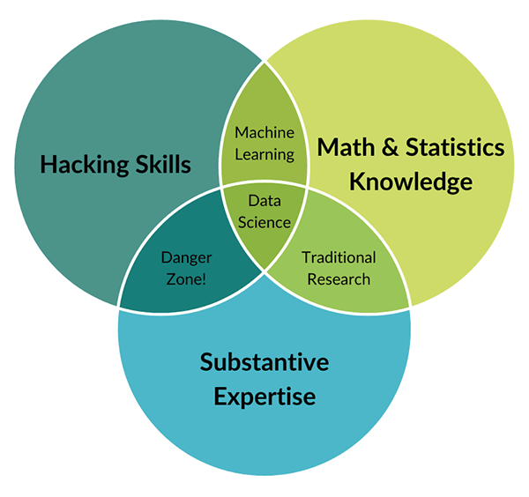

Drew Conway's Venn diagram of data science. ^{[2]}
Conway defines data science as the intersection of three areas: mathematics and statistics, solid programming skills, and expertise in the pertinent subject matter in business, technology, science, engineering, healthcare, government, and beyond.
Data science tackles a range of critical aspects, such as storage infrastructure, complex system design, algorithm scalability, statistical methodologies, visualization techniques, and interaction methodologies, among others. These elements pose significant challenges, especially when grappling with big data, which involves datasets too extensive or intricate for conventional data-processing applications to handle effectively.
Analysis of big data aims to extract actionable insights that enrich decision-making processes and form the foundation for strategic business initiatives. As data continues to expand in volume, velocity, and complexity, the demand for skilled data science professionals intensifies, driving the need for innovative solutions tailored to this evolving landscape.
Example applications of data science across industries include search engine algorithms that rank web pages and predict user queries, targeted advertising that infers user preferences from social networks to deliver relevant ads, recommendation systems in e-commerce platforms like Netflix and Amazon, utilization of electronic medical records in health IT, and data-driven strategies in finance.
References
Godsey, B. (2017) Think like a data scientist: Tackle the data science process step-by-step. Shelter Island, NY: Manning Publications.
Reproduced from Drew Conway (2013) The data science Venn diagram, Drew Conway. Available at: http://drewconway.com/zia/2013/3/26/the-data-science-Venn-diagram(opens in a new tab) (Accessed: 19 June 2024).

A Brief History of Data Science
Although the term ‘data science’ has only recently emerged to specifically designate a new profession expected to make sense of the vast stores of big data, making sense of data has a long history
Data Science was first coined in 1974 by Peter Naur, probably the first reference to the discipline was in 1962 when John W. Tukey wrote The Future of Data Analysis. ^{[1]}
He followed this with Exploratory Data Analysis, arguing that more emphasis needed to be placed on using data to suggest hypotheses to test and that exploratory data analysis and confirmatory data analysis ‘can—and should—proceed side by side’ .^{[2]}
In 1994, Business Week published a cover story titled ‘Database Marketing’, revealing the unsettling news that companies had begun collecting vast amounts of personal information and were planning to launch novel marketing campaigns. This flood of data left many company managers bewildered as they struggled to determine how to utilize such fragmented information effectively.
In 2001, William Cleveland authored a position paper titled ‘Data Science: An Action Plan to Expand the Field of Statistics’ ^{[3]}. In this paper, Cleveland emphasizes the role of the practicing data analyst, asserting that the value of technical areas in data science should be measured by how effectively they facilitate the analyst's learning process. The paper outlines six areas of study for university departments and advocates for the development of specific resources to support research in each of these areas.
Following Cleveland's position paper, the first data science journal was published by the International Council for Science in 2002, coinciding with the introduction of Hadoop in 2006. The term ‘data science’ gained traction as a buzzword in 2008, while 2009 saw the emergence of NoSQL databases through Johan Oskarsson's discussion on open-source, non-relational databases.
By 2011, job listings for data scientists surged by 15,000%, marking the field's rapid growth. This period also saw an increase in seminars and conferences focused on data science and big data, which had become integral to corporate culture. This culminated in Harvard's declaration in 2012 ^{[4]} that data scientists held the sexiest job of the twenty-first century, further propelling the discipline's popularity.
In 2013, IBM revealed that 90% of the world's data had been generated in the preceding two years. The following year, Google's speech recognition system, Google Voice, saw a significant performance improvement of 49% with the adoption of deep learning techniques. Bloomberg noted 2015 as a landmark year for artificial intelligence (AI), with Google initiating over 2,700 AI projects within the year.
Today, there are more than 8,110,000 articles on Google Scholar referring to data science directly. It is also estimated that the market for big data analytics in banking could rise to $62.10 billion by 2025. Data creation is expected to grow to more than 180 zettabytes by 2025. Additionally, data science jobs are projected to increase by around 28% by 2026. The global machine learning market, valued at $8 billion in 2021, is anticipated to grow at a 39% compound annual growth rate (CAGR) by 2027.
References
Tukey, John W. (1962) The Future of Data Analysis. The Institute of Mathematical Statistics.
David, F.N. and Tukey, J.W. (1977) ‘Exploratory Data Analysis’, Biometrics, 33(4), p. 768.
Cleveland, W.S. (2001) ‘Data science: An action plan for expanding the technical areas of the field of statistics’, International Statistical Review, 69(1), pp. 21–26.
Is data scientist still the sexiest job of the 21st century? (2022) Harvard Business Review. Available at: https://hbr.org/2022/07/is-data-scientist-still-the-sexiest-job-of-the-21st-century (Accessed: 03 July 2024).
Why Is Data Science Important?
It has been said that ‘data, and the capability to extract useful knowledge from data, should be regarded as key strategic assets.’ ^{[1]}
In fact, most important decisions are made with only partial information and uncertain outcomes. This degree of uncertainty can be reduced sharply by access to large datasets and the computational tools required to analyze them effectively. Data science provides opportunities for data-driven decision-making while helping to recognize emerging competitive threats rooted in data-driven strategies.
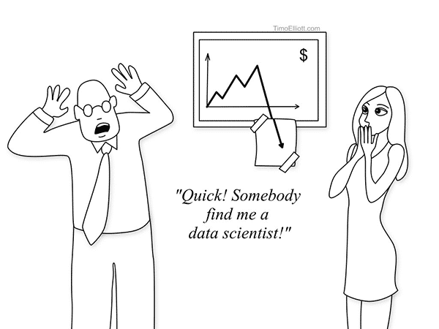
Over the past three decades, data science has expanded globally, becoming indispensable across various sectors like government, genetics, engineering, and astronomy. It has evolved beyond merely scaling up data and integrating new processing systems and analytical approaches.

Data-driven decision-making has already transformed a tremendous breadth of industries, including finance, advertising, manufacturing, and real estate. At the same time, a wide range of academic disciplines are evolving rapidly to incorporate large-scale data analysis into their theory and practice. Even for those who may not directly engage in data science practices, understanding its principles proves indispensable in today's data-driven world.

Watch over the following 8-minute video that provides an explanation of the data science field:
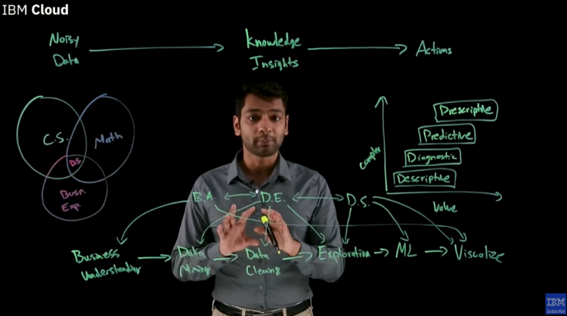
https://www.youtube.com/watch?v=zYGDpG-pTho
References
Data Science Basic - binwei documentation. Available at: https://wubw.github.io/2020/data_science_basic/(opens in a new tab) (Accessed: 03 July 2024).
Innovation evangelism. Available at: https://timoelliott.com/blog/index.php(opens in a new tab) (Accessed: 03 July 2024).
Conclusion
Data science is an evolving field that will be marked by future and innovative advancements in AI and machine learning. Big data technologies will continue to facilitate real-time analytics while expanding data sources from IoT and social media in order to provide richer insights. The demand for skilled data scientists will continue to rise, leading to more educational opportunities and interdisciplinary applications.
Lesson 2: Data Science Pipeline
Introduction

In this lesson, we will briefly examine the data science pipeline, a systematic process used to collect, process, analyze, and interpret data. The pipeline can start where data is generated and stored in any format. The pipeline can end with data being analyzed, used as business information, stored in a data warehouse, or processed in a machine learning model. The pipeline depends on the provider and tooling available. For example, GCP, Azure, NVIDIA, or Amazon have different toolsets for the transformation.
The data science pipeline is essential for transforming raw data into actionable insights. We will revisit most of these topics in more detail later in the course.
Dr. Haidar Harmanani
Data Science Pipeline
Let's explore some of the tasks within the data science pipeline.
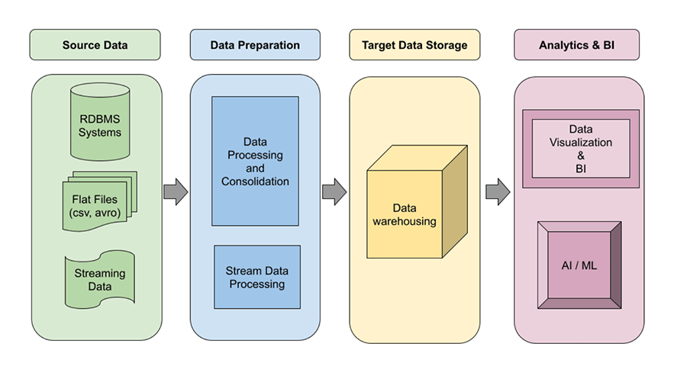
Data Science Pipeline. ^{[1]}
Data Acquisition
One of the initial tasks for data scientists is to collect data relevant to the features of project tasks. Data is typically collected from various sources to ensure relevance and volume for analysis.
These sources include structured databases (like MySQL and MongoDB) containing transactional and operational data, APIs that provide real-time access to data from platforms such as social media sites and financial services, and web scraping tools that automate the extraction of information from websites.
Additionally, with the development of IoT, large datasets, or ‘big data’, are readily available for various projects, including computer vision and natural language processing.
Data Cleaning
Preprocessing the collected data aims to ensure quality and reliability by eliminating irrelevant data that can obscure meaningful patterns.

For instance, collecting text from social media platforms like X (formally Twitter) and Facebook is increasingly challenging due to the evolving nature of social language on these platforms (e.g. using ‘Imma’ instead of ‘I will’).
The data-cleaning process involves filtering out outliers or irrelevant observations that do not contribute to the analysis. Handling missing values is another crucial task, where techniques such as imputation, deletion, or interpolation are used to address gaps in the data. Error correction is also vital, as it entails identifying and rectifying inaccuracies or inconsistencies within the data. This could involve correcting typographical errors, standardizing different formats of the same data (such as date formats), and ensuring that all entries follow a consistent schema.
Finally, data normalization ensures that data is scaled and formatted uniformly, making it suitable for analysis.
Data Exploration
Exploratory data analysis (EDA) is crucial for understanding the data's structure, patterns, and relationships using various statistical and graphical techniques. One of the objectives is to understand the data distribution, revealing its central tendency, variability, and skewness. These could also focus on exploring the relationship between two or more variables, highlighting correlations or clusters within the data.
Feature Engineering
Feature engineering involves the creation of new features or transforming existing ones in order to improve the performance of machine learning models. This process, known as feature engineering, involves various techniques to enhance the dataset's predictive power. These vary from simple techniques such as scaling to encoding categorical variables. Finally, in certain cases, it may be important to derive new variables from existing data.
Modelling
Modeling involves selecting, tuning, evaluating, and training appropriate machine learning or statistical models (e.g. regression, classification, clustering) based on the specific problem and training these models on the prepared data.
Models are evaluated to assess their performance using various metrics. Model tuning optimizes hyperparameters to enhance performance using methods such as grid search, random search, or Bayesian optimization.
Finally, model deployment integrates the trained and validated model into a production environment, enabling it to make predictions on new data, typically through APIs or embedded applications.
Communication and Reporting

Effective communication is essential in data science in order to discuss data patterns, conclusions, and recommendations with stakeholders. This is a crucial task for translating complex data results into clear, actionable information that can drive decision-making.
In most cases, these are accomplished using infographics, reports, interactive dashboards, and presentations.
References
https://cloud.google.com
Modeling Types

Descriptive Versus Predictive Modeling
Descriptive modeling is a technique used to provide an understanding of the current state and historical context of data, offering insights into past behavior and trends. It focuses on summarizing and interpreting historical data to uncover patterns, relationships, and anomalies.
Techniques such as statistical measures are used to summarize data, and visualizations reveal trends and patterns. Additionally, clustering techniques group similar data points to identify natural segments within the data, and association rules find interesting relationships between variables.

Predictive modeling, on the other hand, is typically used to provide actionable insights that support decision-making processes. It employs a variety of statistical, machine learning, and artificial intelligence techniques to build models that can predict future events or behaviors.

Approaches in predictive modeling include regression analysis, classification, time series analysis, ensemble methods, and deep learning techniques.

Supervised Versus Unsupervised Modeling

Supervised modeling involves training a model on a labeled dataset, where each example includes input data and the corresponding correct output. The goal is for the model to learn the mapping from inputs to outputs, enabling it to predict the output for new data.

In contrast, unsupervised modeling trains a model on a dataset without labeled responses, aiming to find hidden patterns and relationships. While supervised learning requires labeled data and provides specific predictions, unsupervised learning works with unlabeled data to reveal underlying structures.

Generative Versus Discriminative Modeling

Generative modeling, exemplified by variational autoencoders, generative adversarial networks, and autoregressive models, possesses the ability to generate new data points resembling those present in the training set, making them well-suited for data generation and synthesis tasks.

In contrast, discriminative modeling seeks to estimate the conditional probability distribution of output labels given input features. Discriminative models excel in predictive tasks where the emphasis is on making precise predictions based on existing data.

Logistic regression, support vector machines, and conditional random fields are popular discriminative models, while Naive Bayes, Bayesian networks, and hidden Markov models are commonly used generative models.
Lesson 3: Data Science Ecosystem
Introduction

The data science ecosystem refers to the set of tools, technologies, frameworks, libraries, and methodologies that enable the end-to-end process of extracting insights and knowledge from data.
It encompasses a wide range of components, including programming languages like Python and R, data storage solutions such as databases and data warehouses, data processing and manipulation tools like pandas and SQL, machine learning frameworks like TensorFlow and scikit-learn, visualization libraries like Matplotlib and ggplot2, and cloud computing platforms like AWS and Google Cloud Platform.
This Ecosystem is dynamic and constantly evolving, with new tools and techniques emerging regularly to address the growing complexity and volume of data.
Dr. Haidar Harmanani
Python For Data Science
To facilitate the end-to-end data science process in this course, we will use Python as the primary programming language, along with its associated frameworks.
While the debate between Python and R continues, the choice of language or platform often boils down to personal preference, as both have their strengths and weaknesses in the realm of data science.
Python's versatility and rich ecosystem of libraries make it well-suited for various tasks encountered in data science. We will leverage Python to extract data from files and databases. These libraries provide powerful tools for reading, transforming, and querying data, enabling us to preprocess and prepare datasets for analysis and modeling.
Data Manipulation Tools
Python libraries such as NumPy and pandas empower analysts to manipulate data with ease, enabling a range of actions including arithmetic operations and visualization.

NumPy is a general-purpose array processing package that provides a high-performance multidimensional array object, known as ndarray, along with tools for working with these arrays.
These ndarrays have several key properties:
•
Rank: The number of dimensions of the array.
•
Shape: A tuple of integers indicating the size of the array along each dimension.
•
dtype: The data type of the array.

On the other hand, pandas revolves around a structure called a DataFrame. A DataFrame is a 2-dimensional structure that organizes data along two axes: the x-axis (rows) and the y-axis (columns). DataFrames provide a table-like structure with columns that can be of different data types, making them highly flexible and powerful for data manipulation and analysis.
Data Visualization Libraries
Python offers several plotting libraries, such as Matplotlib, Seaborn, and many other data visualization packages, each with different features for creating informative, customized, and appealing plots to present data in the simplest and most effective way.
Matplotlib
Matplotlib is a versatile library used for basic graph plotting like line charts, bar graphs, scatter plots, and more. It mainly works with datasets and arrays, making it highly productive when paired with NumPy arrays and pandas DataFrames. Matplotlib regards the axes and figures as objects, providing extensive customization options. This makes it an excellent choice for exploratory data analysis (EDA), where detailed and precise control over plot elements is often required.

Seaborn
Seaborn, on the other hand, is built on top of Matplotlib and is specifically designed for statistical data visualization. It allows for the creation of complex visualizations with fewer commands, making it more efficient for generating insightful statistical graphics. Seaborn treats entire datasets as single units, providing a more organized and functional approach than Matplotlib. It comes with built-in themes and styles that enhance the aesthetics of the plots, making it particularly useful for presenting statistical analyses in a clear and visually appealing manner.

Folium
Folium builds on the data-wrangling strengths of the Python ecosystem and the mapping capabilities of the Leaflet.js library in order to create various types of Leaflet maps. By default, Folium generates a map in a separate HTML file. Since Folium results are interactive, this library is very useful for dashboard building. Additionally, one can create inline Jupyter maps using Folium.
Folium enables users to generate a base map of specified width and height with either default map tile sets (i.e. map styles) or a custom tile set URL. This flexibility allows for the creation of customized, visually appealing, and interactive maps suitable for a wide range of applications.

Machine Learning Toolkits
There is an abundance of Python machine learning libraries, frameworks, toolboxes, and models to choose from. However, perhaps one of the most popular libraries is scikit-learn, which is built on NumPy and SciPy.
Scikit-learn
Scikit-learn supports most classic supervised and unsupervised learning algorithms and can also be used for data mining, modeling, and analysis. Its simple design offers a user-friendly library for those new to machine learning.

TensorFlow
TensorFlow is another popular open-source Python library that specializes in differentiable programming, meaning it can automatically compute a function's derivatives within a high-level language. Both machine learning and deep learning models are easily developed and evaluated with TensorFlow's flexible architecture and framework. TensorFlow can be used to visualize machine learning models on both desktop and mobile platforms.

Keras
Keras is a Python library designed specifically for developing neural network models and can run on top of TensorFlow. Keras is flexible, portable, user-friendly, and easily integrated with multiple functions.

PyTorch
Finally, PyTorch is an open-source machine learning Python library based on the C programming language framework, Torch. It is mainly used in ML applications that involve natural language processing or computer vision. PyTorch is known for being exceptionally fast at executing large, dense datasets and graphs and has become the language of choice on most platforms.
Development Environments
We will be using Jupyter throughout the course, which most likely you may have already seen in other courses.
A Jupyter Notebook is an executable document that is used for interactive development. It allows developers to create and share documents that contain live code,equations, visualizations, and narrative text.
A detailed tutorial regarding notebooks that are hosted by Colab can be found here(opens in a new tab).
A Jupyter Notebook consists of cells which could be either code or mark down cells. A code cell contains actual code that we would like to run.

We can add, delete, or change the type of cells in a notebook. You may check Notebook 1.0(opens in a new tab) for examples.
Finally, Jupyter uses magic functions which can be used to run external code, this may be system or Python code. Magic functions are prefixed by % in the case of line magics or %% in the case of cells magics.
Line-oriented magic functions work like OS command-line calls from within Jupyter. Cell magics, on the other hand, are functions that get as an argument not only the rest of the line, but also the lines below. An example is a magic function that can be used to time a Python function in a Notebook:
Jupyter is now an essential tool that is being used by data scientists and machine learning engineers. Jupyter comes in multiple flavors. It can be locally installed using or as follows:
•
Install Jupyter Lab:
•
Install Jupyter Notebook:
If you decide to use Jupyter locally then you can run it as follows:
•
To run the notebook:
•
To run the lab:
The other option is to use Google Colab(opens in a new tab). Similarly to Jupyter Notebook, Google Colab allows users to combine executable code and rich text in a single document, along with images, HTML, and LaTeX. When you create your own Colab notebooks, they are stored in your Google Drive account.
We recommend using Google Colab for many reasons. The first reason is the ability to share your work with me haidar@ieee.org(opens in a new tab) or with your collaborators. More importantly, Google Colab provides access to free GPU acceleration that would substantially speed up your training.
Watch over the following three-minute video that introduces Google Colaboratory:
https://youtu.be/inN8seMm7UI
Datasets

When data scientists work with data, they are the starting point, not the theories and not the algorithms.
It is crucial to handle data ethically while recognizing that correlations do not imply causal relationships. Moreover, the quality of data holds equal importance to its quantity.
However, preparing and understanding the data constitute one of the most crucial and time-consuming aspects of a deep learning project's life cycle. Studies indicate that data scientists typically dedicate around 70% of their time to analyzing datasets, leaving the remaining time for activities like model selection, training, testing, and deployment.
Consequently, securing a high-quality dataset becomes paramount for any real-world deep learning application. Unfortunately, real-world datasets are often complex, messy, and lack a structured format.
Spend a few moments watching over the following seven-minute video explaining the best places to find datasets for your projects:
https://youtu.be/PExdWWcxmro
Conclusion
The data science ecosystem represents the comprehensive suite of tools, technologies, and methodologies essential for extracting valuable insights from data. Encompassing a diverse array of components, ranging from programming languages to cloud computing platforms, it forms the backbone of modern data analysis and machine learning endeavors. This ecosystem remains dynamic and ever-evolving, adapting to meet the increasing complexity and scale of data challenges. With new tools and techniques continually emerging, it promises to remain at the forefront of innovation in the field of data science, enabling practitioners to unlock deeper insights and drive impactful decision-making processes.

Lesson 4: Data Science Industry
Introduction

Data science involves three closely related domains: analytics, machine learning, and decision science. Graduates who work in these domains are typically known as data engineers, business intelligence analysts, or research scientists.
In this lesson, we will explore the market specificity of data science and discuss the tools that you will be using in this course.
Dr. Haidar Harmanani
Working in Data Science

A data science job mixes three core skills: analytics, machine learning, and decision science.
Data analysts do not use a lot of statistics and machine learning. In general, a data analyst collects data and presents it to the right people using dashboards and reports.

For example, after a company sets its yearly goals, the analyst might put those goals in a dashboard so that management can track progress every week. This work involves a lot of data cleaning and preparation but generally less work to interpret the data. Although analysts should be able to spot and fix data quality issues, the primary person who makes decisions with this data is the business partner.
Thus, the job of an analyst is to take data from within the company, format and arrange it effectively, and deliver that data to others.
A machine learning engineer develops machine learning models and puts them into production, where they run continuously. They may optimize the ranking algorithm for the search results of an e-commerce site, create a recommendation system, or monitor a model in production to ensure that its performance hasn't degraded since it was deployed. A machine learning engineer spends less time on creating visualizations to convince people of something and more time doing the programming work of data science.
Finally, a decision scientist turns a company's raw data into information that helps the company make decisions. This work relies on having a deep understanding of different mathematical and statistical methods and familiarity with business decision-making.
Furthermore, decision scientists have to be able to create compelling visualizations and tables so that the nontechnical people they talk to will understand their analysis. Although a decision scientist does plenty of programming, their work generally gets run only once to make a particular analysis, so they can get away with having code that’s inefficient or difficult to maintain.
The video below provides an explanation of the difference between data engineers, data analysts, and data scientists:
https://youtu.be/eUrwxH9as_k
Selecting a Project

In this course, you will work on two projects, one mid-course and another in the final week. While the final project will be predetermined, you will need to choose the first project.

When choosing a project, work on something that excites you. Ensure the project is interesting, whether computationally or in terms of visualization.

Consider its impact—does it save lives, fight crime, shorten commutes, or save resources?

Select something that is challenging enough to help you learn more. Additionally, browse the list of datasets on Kaggle for inspiration.

G. H. Heilmeier, a director of the Defense Advanced Research Agency (DARPA) between 1975 and 1977, defined a set of questions known as the ‘Heilmeier Catechism’ that anyone proposing a research project or product development effort should be able to answer.

These include:

1
What are you trying to do? Articulate your objectives using absolutely no jargon.

2
How is it done today; what are the limits of current practice?

3
What's new in your approach; why will it be successful?

4
Who cares?

5
If you're successful, what difference and impact will it make?

6
How do you measure them (e.g. via user studies, ground truth data)?

7
What are the risks and payoffs?

8
How much will it cost?

9
How long will it take?
10 What are the midterm and final ‘exams’ to check for success?

Working in Teams
Data scientists work in teams because effective collaboration is essential. This starts with proper introductions and building rapport through shared interests, which form the basis for strong working relationships.
To foster effective collaboration, it is important to meet people properly and establish a good rapport. Find common interests to build a foundation for a strong working relationship.

This will ensure that meeting conditions are conducive to productive discussions and that everyone has the opportunity to contribute. Maintain humility by checking your egos at the door, and offer praise to acknowledge each other's contributions. Document important points and decisions in writing to avoid misunderstandings. Be open and honest in your communications, while striving to avoid conflict. When presenting alternatives, phrase them as questions to encourage constructive dialogue.
Potential member roles in a team are varied and often overlap, with one member possibly playing multiple roles. These roles include domain experts, software and system engineers, machine learning model developers and auditors, visualization, interaction, and user experience designers, statisticians, data engineers, business analysts, and project and product managers.
Git, GitHub, and Version Control

Let's explore how you may be able to collaborate effectively as a team.

Git is one of the most popular version control systems, designed to manage projects as they evolve over time by tracking the source code history. All of this information is stored within a repository.

GitHub is a cloud-based hosting service that allows you to manage Git repositories. It enables seamless work on your local computer, with the ability to commit changes to a repository owned by yourself or a collaborator that is stored remotely. This is particularly useful when developing software or working on a data science project with a team.

Essentially, you can think of GitHub as the ‘Dropbox’ for coding projects.

Like most aspects of data science, you will get different answers from different people, but one thing is clear: version control is integral to the development process. Git provides a complete history of every change ever made to your project, including timestamps, comments, and attributions. If something breaks, you can always revert to a previous state. This is incredibly useful for complex data science projects, eliminating the need for multiple versions of files.

By using Git properly, you keep new changes separate from a stable base, which helps avoid the massive rollbacks associated with constantly tinkering with a single codebase. Additionally, Git allows you to pinpoint when a particular piece of code was changed, making it easy to determine what other pieces of code a bug might affect or to understand why a certain change was made. In team-based projects, different people can work on the same files simultaneously, facilitating collaboration and efficient project management.

A Git repository contains commit objects, each containing a set of files that reflect the project at a given point in time, references to the parent commit objects, and a 40-character string identifier called a SHA1 name. Parent commit objects are those commits that were edited to produce the subsequent state of the project, so the initial commit will not have references. An identical commit will have the same SHA1 name. References to commit objects are called heads. By default, this is named master, though it can be changed, which is useful for debugging.

There are several key concepts and commands in git. When you are working on your local machine you typically get started by:

•
git clone: Cloning a remote repository to work on locally. This is a way to work with an ongoing project or edit someone else's project that is available remotely (aka on GitHub).

From there, the typical workflow involves:

•
git add: Adding files to your repo.

•
git commit: Committing changes you have made.

•
git push: Pushing changes to a remote repository (aka GitHub).

•
git pull: Pulling changes from a remote repository, this is useful for a collaborative project or for a project that you work on in several local environments (e.g. work desktop, personal laptop).

An overview of this process is provided in the figure below:

Data science pipeline.

Next week we will work with these commands within Bash, a command line interface, to get some practice.

GitHub, on the other hand, is an internet hosting service designed to store Git repositories. It allows for easy interaction with Git. Git and GitHub can track multiple branches (versions) of the same repository, so contributors can make changes in parallel without affecting the main/master branch. GitHub offers a range of benefits, including:

•
Teams can utilize it as a centralized hub to manage a collective codebase.

•
Individuals working on solo projects can leverage it for repository backups and seamless collaboration across multiple devices.

•
While maintaining a personal git repository locally on one's machine is always an option, Github provides additional functionality.

•
Each contributor to a repository receives a copy, enabling independent work.

•
Other analogous services like Bitbucket and Gitlab are also available in the market.

The video below provides an extensive introduction to Git and GitHub. At forty-five minutes in length means that, while not all of the tutorial is required, it serves as a good reference in case you run into any hiccups:
https://youtu.be/tRZGeaHPoaw
Ethical Dimension

It is essential to use ethical guides throughout the lifecycle of a data science project.
This involves upholding principles such as privacy, fairness, transparency, and accountability to ensure that data-driven processes respect individuals' rights, mitigate biases, and promote equitable outcomes.
Ethical data science practices involve securing sensitive information, providing clear explanations of methodologies, and establishing mechanisms for accountability and redress in case of errors or harm. Additionally, ethical considerations extend to the broader societal impact of data science initiatives, emphasizing positive social outcomes and informed consent. Collaboration among diverse stakeholders is crucial for developing ethical frameworks and guidelines that balance innovation with ethical responsibility, ultimately fostering trust and maximizing the societal benefits of data-driven approaches.
Let us take a look at a couple of examples. In the 2016 US election, Cambridge Analytica improperly accessed Facebook data and used that for political ad targeting. Algorithms are used to predict the risk that criminals will re-offend and to sentence them accordingly. Some airlines assign families to separate seats, forcing them to pay extra to sit together. ‘Data ethics’ purports to provide answers to these questions or at least a framework for wrestling with them.
Conclusion
The field of data science comprises three interrelated domains: analytics, machine learning, and decision science, which collectively offer diverse career opportunities for graduates, including roles such as data engineers, business intelligence analysts, and research scientists. As we delve into the specifics of the data science market, this lesson looked at some tools that are essential for navigating this dynamic and evolving field.

Week 2
Overview
This week covers four topics. We start with another review of pandas, focusing on handling data with Python. We will then delve into exploratory data analysis (EDA), discussing data structure, key features, descriptive statistics, and correlation, culminating in practical exercises and comparative analysis. Next, we will address various data formats, including CSV, JSON, Parquet, and Zip. Finally, we will conclude with time series data, covering date and time in Python and indexing date and time.
Learning Outcomes
By the end of this week, you will be able to:
Review pandas basics such as series and dataframes.
Identify the various file types and the differences between them.
Gain proficiency in various facets of data.
Use essential functionalities of pandas including series, dataframes, and querying.
Manage data spanning across dates and times.

Lesson 1: Handling Data With Python
In this lesson, we will review pandas, an open-source data analysis library for Python. We will explore series and dataframes, along with relevant manipulation tools. Additionally, we will examine the built-in features such as indexing, selecting, and assigning values in dataframes, as well as various tools for filtering, querying, and manipulating data.
Dr. Haidar Harmanani

Background and Installation
Let's explore some of the background of the pandas library, and the steps needed to install it.
Background
Pandas (styled as pandas) is an open-source data analysis library for Python. The name ‘Pandas’ comes from the econometrics term ‘panel data’ describing datasets that include observations over multiple time periods. The pandas library was created asa high-level tool or building block for doing very practical real-world analysis in Python.
Pandas provides high-performance, easy-to-use data structures that store data in tabular data structures called Series and Dataframes. Pandas strengthens Python by providing the capability to work with spreadsheet-like data enabling fast loading, aligning, manipulating, and merging, in addition to other key functions.
Pandas provides tools and functionalities to import and visualize data. Data can be imported from flat files such as CSV, XLS, JSON, and Parquet, as well as from databases and even online links. Furthermore, pandas comes with a myriad of built-in features for data science and machine learning tasks.
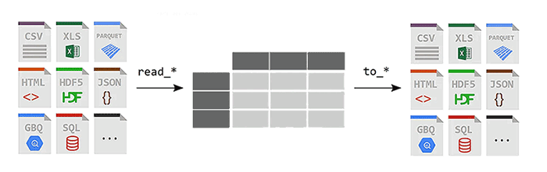
Pandas allows for importing and exporting tabular data in various formats, such as CSV or JSON files. ^{[1]}
Pandas, often hailed as a 'game changer' for data analysis with Python, is among the most popular and widely used tools for data wrangling, or munging. This term refers to the process of transforming data from unusable or erroneous forms to the structured and high-quality formats required for modern analytics processing. Pandas excels in handling structured data formats such as tables, matrices, and time series data. Additionally, it integrates seamlessly with other Python scientific libraries.
You may consult with the following data sheet for data wrangling(opens in a new tab) with pandas.
Installation
There is no need to worry about pandas if you are using Google Colab. You may, however, install it on your own machine using pip or using conda as you may recall from earlier in the program:
pip install pandas
Or the following for Python 3:
pip3 install pandas
As for conda, you may install as Pandas as follows:
conda install pandas
References
P. kumar (2024) Python pandas, Medium. Available at: https://medium.com/@pavanreddy1828/python-pandas-381412a4b32a(opens in a new tab) (Accessed: 23 July 2024).

Creating Series
A pandas Series is a data structure that stores data in the form of a column. A Series is normally used to store information about a particular attribute in your dataset.

One way to create a Series in pandas is using the Series() class constructor, which creates an empty series:

# Create an empty series

import pandas as pd

my_series = pd.Series()

Another way is to create a Series from a NumPy array as follows:

# Create and instantiate a pandas Series

import pandas as pd

import numpy as np

my_array = np.array([10, 20, 30, 40, 50])
my_series = pd.Series(my_array)

Finally, you can also create a Series using a dictionary. In this case, the dictionary keys will become Series indexes, while the dictionary values are inserted as Series items:

import pandas as pd

# series using dictionary
my_dict = {'num1': 6, 'num2': 7, 'num3': 8}
my_series = pd.Series(my_dict)

A Series can be converted back to a dictionary with its to_dict() method:

my_series.to_dict()

Creating Dataframes
A pandas DataFrame is a tabular data structure that stores data in the form of rows and columns. As a standard, the rows correspond to records while columns refer to attributes.

Put simply, a pandas DataFrame is a collection of Series. You can think of a DataFrame as a spreadsheet, a SQL table, or a dictionary of Series objects.
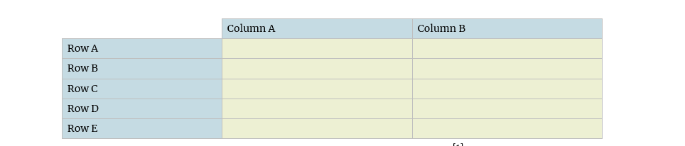

A visual representation of a pandas DataFrame with five rows and two columns. [1]

There are multiple ways to create a pandas DataFrame. One can simply create an empty DataFrame using the DataFrame class as follows:

# empty pandas dataframe

import pandas as pd

my_df = pd.DataFrame()

You can also create a pandas DataFrame using a list of lists where each sublist in the outer list corresponds to a row in the DataFrame. Each item within a sublist becomes an attribute value:

# Dataframe using list of lists

import pandas as pd

scores = [['Mathematics', 85], ['English', 91], ['History', 95]]
my_df = pd.DataFrame(scores, columns = ['Subject', 'Score'])

Finally, a DataFrame can be created using a dictionary where the keys correspond to column headers and corresponding dictionary values are the column values:

# dataframe using dictionaries

import pandas as pd

scores = {
'Subject':['Mathematics', 'History', 'English', 'Science', 'Arts'],
'Score':[98, 75, 68, 82, 99]
}
my_df = pd.DataFrame(scores)

References

Reproduced based on Paskhaver, B. (2021) Pandas in action. Shelter Island, NY: Manning Publications.

Reading Data From Files

Let's have a look at how we can read data from files.
You can read CSV files using the function of the pandas DataFrame, as shown in the below import pandas as pd:
my_data = pd.read_csv('iris_data.csv')
Or one can read an Excel file as follows:
pd.read_excel('tmp.xlsx', index_col=0)
You may also read JSON files using read_json(). More about JSON and other file notations later in the week.
import pandas as pd
import json
df = pd.read_json('data.json')
print(df.to_string())
A popular method to get a peek into a small sample of big data is the use of the head()and tails() methods:
import pandas as pd
head_long_df = df.head()
tail_long_df = df.tail(3)

Indexing, Selecting, and Assigning
The pandas Series and DataFrame objects contain an explicit index that allows us to reference and modify data.
The Index object is a structure that can be thought of either as an immutable array or as an ordered set.
import pandas as pd
ind = pd.Index([2, 3, 5, 7, 11])
Pandas objects have several attributes that provide access to metadata. These include the shape, which gives the dimensions of the object, and labels. While Series have only an index axis, DataFrames have both index (rows) and columns.
In fact, pandas objects can be thought of as containers for arrays, which hold the actual data and perform the computations. To access the actual data within an Index or Series, use the var.array property:
import pandas as pd
s.array
s.index.array
Pandas DataFrames can also be sorted in descending order:
import pandas as pd
# The two lines below are equivalent
df = pd.read_csv("nba.csv", parse_dates = ["Birthday"])
df.sort_values("Name")
df.sort_values(by = "Name")
Or in reverse alphabetical order:
import pandas as pd
df.sort_values("Name", ascending = False)
Or by multiple columns:
import pandas as pd
df.sort_values(by = ["Team", "Name"])
A column can also be selected using the square-bracket syntax or using the dot syntax:
#These two lines are equivalent
position = df.Position
position = df["Position"]
Also, one can extract DataFrame rows by index label or position:
df.loc["LeBron James"]
Or using a list in between the square brackets to extract multiple rows.
df.loc[["Kawhi Leonard", "Paul George"]]
Finally, one can use loc slicing to pull rows from the beginning of the DataFrame to a specific index label. Start with a colon and then enter the index label to extract to. The next example returns all players from the start of the dataset up to Al Horford:
In [69] df.sort_index().loc[:"Al Horford"]
Grouped and Aggregated Calculations
In this section, we will consider grouped and aggregated calculations.
Let us consider a surveillance report from the National Institute on Alcohol Abuse and Alcoholism, niaaa_report.csv having the following structure:
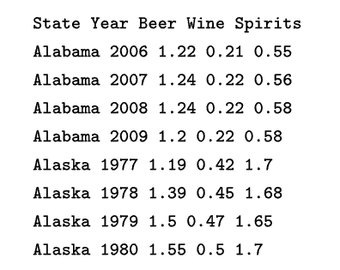
There are several initial questions that we could ask ourselves:
•For each year in our data, what was the average consumption?
•What if we stratify the data by state and perform the same calculations?
•How many states are listed?
To answer the questions just posed, we need to perform a grouped (i.e. aggregate) calculation. In other words, we need to perform a calculation, be it an average or a frequency count, but apply it to each subset of a variable.
Another way to think about grouped calculations is as a split–apply–combine process. We first split our data into various parts, then apply a function (or calculation) of our choosing to each of the split parts, and finally combine all the individual split calculations into a single dataframe.
We accomplish grouped (i.e. aggregate) computations by using the method on DataFrames:
import pandas as pd
alcohool = pd.read_csv("niaaa-report.csv")
alcohool.groupby('State')['Beer'].std()
continent_describe = df.groupby('continent')["lifeExp"].describe()
The following is a bit more complex as we read the data from a file, calculate descriptive statistics, and then perform a simple data aggregation:
import pandas as pd
df = pd.read_csv('/data/temp.csv')
(
df
.groupby(by='category')
.agg({'num': 'sum', 'char': 'count'})
.reset_index()
)

Filtering, Querying, and Manipulating Data
Pandas provides various methods for filtering, querying, and manipulating data.
Our aim is to just introduce some of the interesting methods as it may be difficult to cover all of these within the scope of this lesson.
Dataframes can be queried using the query method. Then they can be also merged or joined in a similar way to what we do in databases. For example, the following joins two DataFrames that have a common column. The lsuffix and rsuffix parameters are necessary here because the data has the same column names in both British and Canadian datasets. If this wasn't true we wouldn't need them:
left = canadian_youtube.set_index(['title', 'trending_date'])
right = british_youtube.set_index(['title', 'trending_date'])
left.join(right, lsuffix='_CAN', rsuffix='_UK')
We can also concatenate:
pd.concat([canadian_youtube, british_youtube])
We can also use the append() function to concatenate the pandas DataFrame of Series objects. The main difference is that append() can append two DataFrames at once while can concatenate multiple DataFrames.
We can also filter data based on a specific criterion:
df.query('Score > 4 and Score < 10')
Data Pitfalls
With messy data, there is always a risk of missing or misinterpret information.
For example, popular operating systems have not agreed on a single way to denote line endings in text files. Linux uses the line feed (LF) to indicate a new line, whereas versions of Mac OS before version 9.0 used the carriage return (CR) character for a new line. Since 1999, Mac OS has joined other Unix derivatives in using the line feed to denote a new line, but Microsoft Windows continues to use a hybrid CR+LF line ending.
One more issue to usually keep an eye on is the interpretation of escape characters in Python.
An escape character is a character followed by a backslash (\textbackslash). It tells the Interpreter that this escape character (sequence) has a special meaning. Unless an 'r' or 'R' prefix is present, escape sequences in string and bytes literals are interpreted according to rules similar to those used by Standard C. In Python, a string becomes a raw string if it is prefixed with "r" or "R" before the quotation symbols.
Hence 'Hello' is a normal string whereas r'Hello' is a raw string.

Lesson 2
Introduction
In this lesson, we will explore exploratory data analysis (EDA), a critical step in the data analysis process. The term EDA comes from the work of John W. Tukey, a prominent figure in modern statistical methodology. In his 1977 book Exploratory Data Analysis,[1] Tukey conceptualized EDA as a method to explore data, uncover evidence, and develop hypotheses that could later be confirmed by statistical tests.
Dr. Haidar Harmanani

Exploratory Data Analysis
Exploratory data analysis (EDA) involves providing descriptive and graphical summaries of the data to comprehend its nature, and relationships between variables, and to identify potential issues such as missing values, outliers, or data entry errors.
This method allows for an exploration of the data without the need to make any assumptions, providing a foundation for further analysis and decision-making. EDA is also used to visualize data distributions and relationships between variables.
EDA is an iterative process, allowing analysts to formulate hypotheses, test assumptions, and refine their understanding of the data. By providing a clear and comprehensive overview of the dataset, EDA lays the groundwork for more sophisticated statistical analysis and machine learning models, ensuring that insights and conclusions drawn from the data are accurate and reliable.

Getting data for your data science projects typically involves one of three scenarios: you may either be provided with the required data, tasked with downloading it from online sources, or required to scrape data from the web directly.
Each of these approaches presents its own challenges and considerations, but all are essential steps in the data science workflow, laying the groundwork for subsequent analysis and exploration.
Revealing Structure of Data

Understanding the underlying structure of the data is essential for selecting appropriate machine learning methods for modeling and making future predictions. Exploratory data analysis (EDA) employs various techniques to unveil this structure and provide insights into the data's characteristics.
Univariate Analysis
Univariate analysis focuses on individual variables, using tools such as histograms and box plots to summarize their distributions.
This type of analysis helps in identifying the central tendency, variability, and distribution shape of a single variable. Univariate visualization provides summary statistics for each feature or variable, aiding in data profiling and offering a better understanding of the dataset through statistical measurements.
This foundational step is crucial for detecting outliers, understanding the spread and skewness of the data, and making preliminary assumptions about the variable's behavior.
Bivariate Analysis
Bivariate analysis explores the relationship between two variables. It utilizes visualization tools such as scatter plots, correlation matrices, and line plots to understand how one variable affects or relates to another.
Bivariate visualization often includes the target variable of interest and helps in identifying correlations, trends, and potential causal relationships. This type of analysis is particularly useful for feature selection and engineering, as it highlights which variables might be most relevant for predictive modeling.
Multivariate Analysis
Multivariate analysis examines interactions between three or more variables simultaneously. This type of analysis uses more complex visualization methods, including scatter plot matrices, parallel coordinates plots, and color-coded matrices, to reveal intricate relationships and dependencies among multiple features.
Multivariate visualization helps in understanding the combined effect of multiple variables on the target variable, identifying higher-dimensional patterns, and detecting multicollinearity among features. It is instrumental in building robust predictive models, as it provides a comprehensive view of how different variables interact and influence each other.
Visual exploratory data analysis can be achieved by starting with the examination of each distinct feature (univariate analysis), then comparing pairs of variables (bivariate analysis, such as in a scatterplot), and finally considering multiple features together (a multivariate approach).
If you're feeling uncertain about where to start, relying on automated strategies can be helpful. For instance, AutoViz(opens in a new tab), a popular rapid EDA freeware tool, can save you a lot of time. You can install it in your notebook by running the following command:
!pip3 install autoviz

Data Features
In the context of data analysis, data is typically broadly categorized into two main types: categorical and numerical.
This categorization is important since the type of analysis you can conduct varies depending on the nature of the variables involved.
Categorical
Categorical features come in two main types: nominal and ordinal.
Nominal features, like gender, species names, or countries, have a finite set of values and are represented either as strings or as numerical codes without any inherent numerical significance. For instance, representing countries with numerical codes like 1 for Afghanistan, 2 for Albania, and so forth doesn't imply meaningful arithmetic operations on these values.
On the other hand, ordinal features also have a finite set of values, but unlike nominal features, the order of these values matters. For example, a Likert scale rating ranging from 1 for ‘very unlikely’ to 5 for ‘very likely’ is an ordinal feature. However, performing arithmetic operations on ordinal values is generally inappropriate as there's no consistent or meaningful distance between the values.
Numerical
Numerical data, as the name suggests, consists of numbers and can be further classified into two types: discrete and continuous.
Discrete data represents countable values with gaps between possible values, such as the number of students in a classroom or the number of cars in a parking lot.
Continuous data, on the other hand, can take any value within a given range and often represents measurements, such as height, weight, or temperature.
Structured or Unstructured
Finally, data can be classified as either structured or unstructured, noting that structured data frequently originates from unstructured sources and undergoes a process of organization.
Watch over the following two-minute video, which provides an explanation of the types of statistical data:
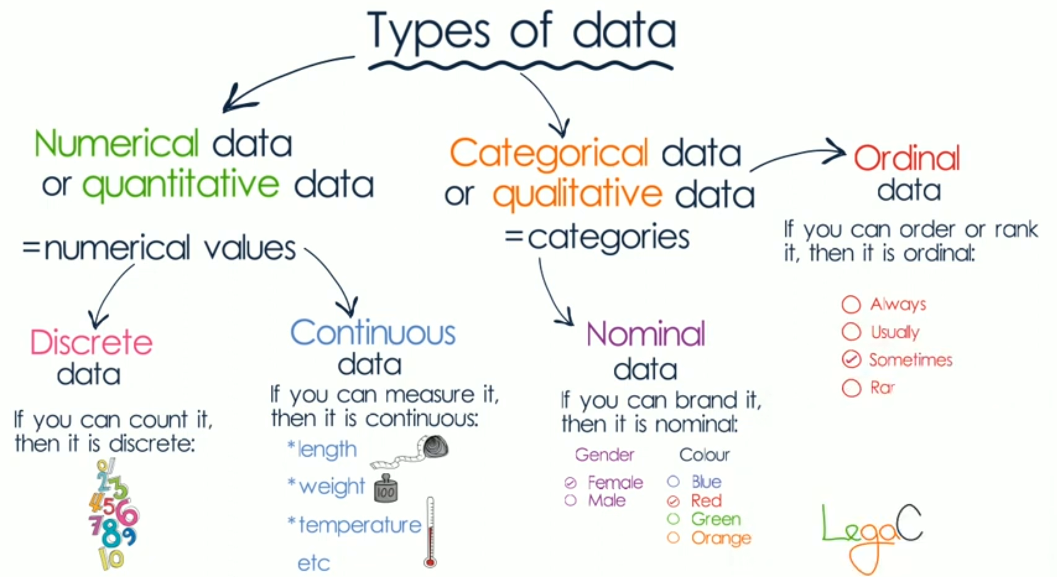

Descriptive Statistical Information

Descriptive statistical functions calculate Sum() , mean(),median() , standard deviation std(),count() ,min() ,max() and of a Series or each column in a DataFrame.
Each function can take the Boolean parameter skipna , which specifies whether to exclude NaNs from the analysis, and the axis parameter, which indicates the direction of the calculation (‘vertically’ or ‘horizontally’).

To illustrate these concepts, let's consider a dataset derived from the 2011 surveillance report by the US National Institute on Alcohol Abuse and Alcoholism. The report provides per capita alcohol consumption data per state, categorized by beer, wine, and spirits, spanning the years 1977 to 2009:
import pandas as pd
alcohool = pd.read_csv("niaaa-report2009.csv", index_col ='State')
To obtain straightforward statistical information, we can utilize descriptive statistics to summarize the key characteristics of our data:
alcohool.max()
alcohool.min()
alcohool['Beer'].median()
alcohool['Wine'].std()
The describe()method in pandas is a convenient way to get a quick overview of your data. By default, it provides the count, mean, standard deviation, minimum, 25th percentile (Q1), median (50th percentile or Q2), 75th percentile (Q3), and maximum values of the columns:
alcohool.describe()
The functions argmax()(for Series) and idxmax() (for DataFrames) identify the index positions of the first occurrences of the maximal values within the data structures.
Interestingly, these are the only two functions in pandas that exhibit inconsistency in their treatment of Series and DataFrames:
alcohool.idxmax()
Pandas has limited support for pseudo-integration, pseudo-differentiation, and other cumulative methods. The functions cumsum(),cumprod() ,cummin() ,cummax() and calculate cumulative sums, products, minimums, and maximums, starting from the first item in the Series or each DataFrame column:
alcohool.loc[:'Hawaii'].cumsum().head()
Let's take a break in this lesson for a short exercise to explore the functions we have discussed so far!

Pearson Correlation Method

The common concept of correlation—specifically the Pearson correlation coefficient—assumes a linear model, though this fact is often overlooked or not widely known.
The next time you read a forecast for an upcoming election, remember that the predictions and margins of error are based on a linear model.
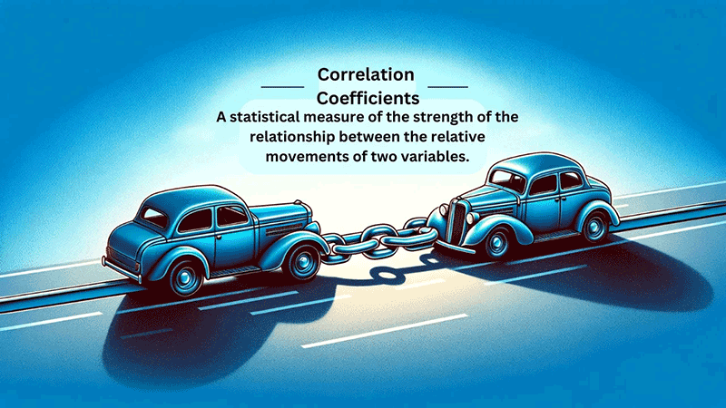
Correlation is a statistical measure that describes the strength and direction of the relationship between two variables. ^{[1]} It quantifies how changes in one variable are associated with changes in another.
The most commonly used correlation coefficient is the Pearson correlation coefficient, , which is a measure of the strength of the linear relationship between two variables. It is referred to as Pearson's correlation or simply as the correlation coefficient. If the relationship between the variables is not linear, then the correlation coefficient does not adequately represent the strength of the relationship between the variables.
Pearson's ranges from -1 to 1, where +1 indicates a perfect positive linear relationship, -1 indicates a perfect negative linear relationship, and 0 indicates no linear relationship:
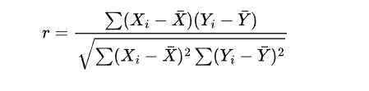
Where:
• Xi and Yi and are the individual data points.
• X~ is the mean of the X values.
•Y~ is the mean of the Y values.
A positive correlation means that as one variable increases, the other tends to increase as well. Conversely, a negative correlation means that as one variable increases, the other tends to decrease. When there is zero correlation, no linear relationship exists between the two variables:
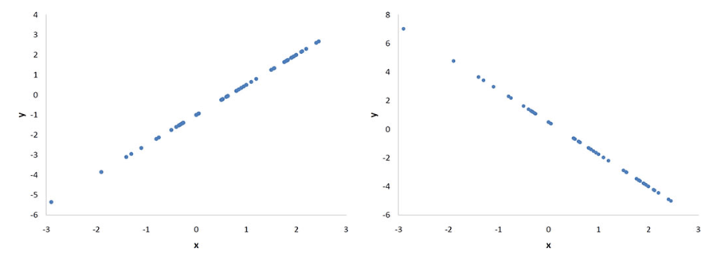
Illustrating the Pearson correlation coefficient (Left: A perfect positive linear relationship, =1. Right: A perfect negative linear relationship, =-1.). ^{[2]}
import pandas as pd
data = {'x': [1, 2, 3, 4, 5, 6, 7, 8, 9, 10], 'y': [5, 10, 10, 15, 14, 15, 19, 18, 25, 23]}
df = pd.DataFrame(data)
# Print correlations between variables
correlations = df.corr(method='pearson')
print(correlations)
The output here will be:
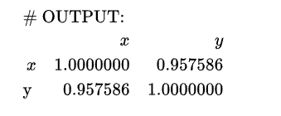
It is important to consider that the Pearson correlation coefficient assumes a linear relationship and that correlation does not imply causation. A high correlation between two variables does not necessarily mean that one causes the other to change. Additionally, outliers can significantly affect the correlation coefficient, so handling extreme values carefully is essential.
References
- Ghelbur, E. (2023) Understanding and interpreting correlation coefficients, Medium. Available at: https://medium.com/@e.ghelbur/understanding-and-interpreting-correlation-coefficients-d733ebb2bbd7(opens in a new tab) (Accessed: 25 July 2024).
- Libretexts (2022) 4.2: Values of the Pearson correlation, Statistics LibreTexts. Available at: https://stats.libretexts.org/Bookshelves/Introductory_Statistics/Introductory_Statistics_(Lane)/04%3A_Describing_Bivariate_Data/4.02%3A_Values_of_the_Pearson_Correlation(opens in a new tab) (Accessed: 25 July 2024).

Chi-Square Test

The chi-squared test is a non-parametric statistical method frequently used in data science, especially when dealing with categorical data. It is useful for assessing the relationship between two categorical variables in a sample. There are two types of chi-squared tests: the chi-squared test of independence and the chi-squared goodness of fit test.
The chi-squared test of independence assesses whether there is a significant association between two categorical variables. In contrast, the chi-squared goodness of fit test determines if the observed frequencies for a categorical variable match an expected set of frequencies. Both tests are essential tools in data science for analyzing categorical data.
The chi-square test of independence is commonly used to test for statistical independence or association between two categorical variables:
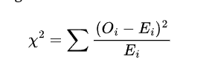
Where:
•X2 is the chi-square statistic.
•Oi represents the observed frequency of thei th category.
•Ei represents the expected frequency of the ith category under the assumption of independence.
The chi-square test of independence can only compare categorical variables and is not suitable for comparisons between continuous variables or between categorical and continuous variables. Additionally, it only assesses associations between categorical variables and cannot provide any inferences about causation.
It can be computed in Python as follows:
import numpy as np
from scipy.stats import chi2_contingency
# Example contingency table (observed frequencies)
observed = np.array([
[30, 40, 50],
[9, 12, 20]
])
# Compute the Chi-Square Test of Independence
chi2, p, dof, expected = chi2_contingency(observed)
# Print the results
print(f"Chi-Square Statistic: {chi2}")
print(f"P-value: {p}")
print(f"Degrees of Freedom: {dof}")
print("Expected Frequencies:")
print(expected)
In this lesson, we delved into the critical practice of exploratory data analysis (EDA), which serves as a foundational step in understanding the underlying structure of datasets. EDA involves a comprehensive examination of data through descriptive statistics, visualization techniques, and statistical analyses. We also explored the significance of establishing correlations between different features within the dataset.

Lesson 3: Data Formats

Introduction
Data comes in multiple forms, but it should meet several key criteria to be effective. It should be scalable in terms of reading and writing, ensuring it can handle varying volumes efficiently. Scalability should also apply to speed and cost, enabling the system to perform well under different loads and within budget constraints. Flexibility is crucial, both in how data is stored and how it is utilized by applications. Finally, data should be functional, providing the necessary capabilities for both server-side and client-side operations.
Dr. Haidar Harmanani

CSV
The first file format we'll discuss is the ubiquitous csv(Comma Separated Values) file type.
Csv files, familiar to many through spreadsheet tools such as Microsoft Excel and Google Sheets, are human-readable and stored in text format. In a csv file, each line represents a row of data, and within each line, fields are separated by commas (hence the name). This format is optimized for tabular data, making it ideal for scenarios where data exchange between various applications is required due to its simplicity and universal support.
We will use the following file to illustrate the different formats whenever applicable:
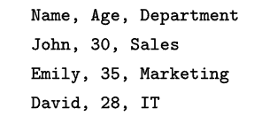
csv files are commonly used for exchanging data between different software applications because they are easy to read and write, and they can be opened with many spreadsheet programs. However, they may suffer from slow loading times and larger file sizes, particularly when dealing with extensive datasets due to their text-based format.
As shown earlier on, a file can be read in pandas using the .read_csv function:
import pandas as pd
df = pd.read_csv(file_path)

JSON
JSON is a functional format: it is human-readable and its tree-like data structure supports the quick reading and writing of multiple data types.
This versatility makes it widely used in many applications. Almost every web application likely utilizesJSON , enabling users to interact with websites in various ways, such as clicking a radio button, typing in a text field, or selecting a date from a calendar. JSON can be easily sent back and forth between the front end and the back end as data is stored and retrieved from back-end databases. However, JSON is semi-structured and doesn't scale as efficiently to millions or billions of data points.
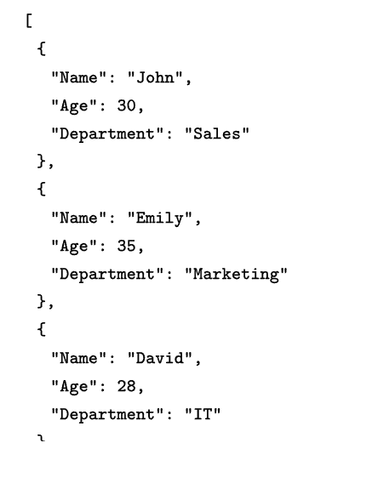
Although in most cases JSON data is read using APIs, they could be loaded into pandas' DataFrame using .read_json :
import pandas as pd
df = pd.read_json(file_path)
Another common way to read JSON is by pulling the data directly using a web API. In this case, we would need to craft a URL(opens in a new tab) to retrieve data from it. APIs are usually flexible and use several parameters:
with urllib.request.urlopen(url) as url:
data = json.loads(url.read().decode())
JSON.dumps, on the other hand, converts a Python object back to :
answer_json = json.dumps(data)
The following is a simple workable example reading data from GitHub:
from urllib.request import urlopen
import json
import ssl
ssl._create_default_https_context = ssl._create_stdlib_context
url = "https://api.github.com"
response = urlopen(url)
data_json = json.loads(response.read())
print(data_json)
It should be noted that in many instances, APIs provide live data, and there is a chance that they may be experiencing downtime. Additionally, many APIs require a key and registration in order to grant access.

Parquet
Parquet from Apache is a columnar storage format that uses compression techniques resulting in improved query performance and reduced storage requirements.
This format is especially suitable for big data analytics tasks where efficient storage and retrieval are crucial. Additionally, PArquet files support schema evolution, allowing for changes to the schema without requiring modifications to existing data. However, they may be less human-readable compared to CSV files and may require specific software support for manipulation and analysis.A link to Parquet can be found here (opens in a new tab).

In Parquet and other columnar formats, each column of data is stored independently, providing multiple benefits. Firstly, with structured data, each column has a specific type. For example, Name and Role might be strings, while ‘Age’ is an integer. Storing data by columns allows for type-specific encoding and compression, enhancing efficiency. Unlike , CSV files which treat all data as strings, Parquet files include an explicit schema and metadata within the file itself, avoiding inefficiencies.
Secondly, because columns are stored separately, it is possible to load only the needed columns efficiently. For instance, a query like ‘SELECT name, role From table can be executed more quickly as only the required columns are loaded. Similarly, operations such as Selecr Average age from table are faster because all relevant data for the column is contiguous in memory.
A file may be read as follows:
import pandas as pd
df = pd.read_parquet(file_path)
files cannot be visually inspected directly as they are binary files, and attempting to view them will result in unreadable gibberish.
Zip
Zip s a widely-used file format designed to compress one or more files into a single location, reducing their overall size and facilitating transportation or storage. Recipients can easily unzip or extract the contents of a Zipe file and access the original files.
Functionally, ZIP files operate similarly to standard folders on a computer, containing multiple files grouped together. However, ZIP files compress the contents, thereby reducing the amount of data used by the computer. Essentially, a ZIP file serves as an archive, housing all compressed files in one convenient location. Therefore, utilizing theZIP file format is an effective way to decrease the size of individual files or groups of files.
import pandas as pd
df = pd.read_csv(file_path)
df_cpu = pd.read_csv(file_path, compression="zip")

Conversions Across File Types
Reading files is useful, but so is the ability to write them.
A ,CSV ,Parquet and ZIP can be converted to any format. It should be noted that using Parquet requires the installation of pyarrows:
pip3 install pyarrow
First, to_csv(opens in a new tab) parquet can be used to convert a Parquet file to a CSV file:
import pandas as pd
df = pd.read_parquet('nba.parquet')
df.to_csv('nba.csv')
A CSV can be converted to a ZIP file using the compression parameter of to_CSV:
import pandas as pd
df = pd.read_csv('nba.csv')
df.to_csv('nba.zip', compression="zip", index=False)
A CSV file can be converted to a PArquest file using the .parquet function:
import pandas as pd
df = pd.read_csv('nba.csv')
df.to_parquet('nba.parquet')

Conclusion
Effective data management requires data to meet several key criteria. Data representations should be scalable in terms of reading, writing, speed, and cost, ensuring efficient handling of varying volumes within budget constraints. Flexibility is essential in both storage methods and application utilization. Additionally, data must be functional, offering necessary capabilities for both server-side and client-side operations.
Lesson 4: Handling Time Series

Introduction

In this lesson, we will explore time series data with a focus on date and time. Time series data is an important form of structured data in many different fields, such as finance, economics, ecology, neuroscience, and physics. Anything that is recorded repeatedly at many points in time forms a time series. Many time series are fixed frequency, which means that data points occur at regular intervals according to some rule, such as every 15 seconds, every 5 minutes, or once per month. Time series can also be irregular, without a fixed unit of time or offset between units. How you mark and refer to time series data depends on the application, and you may have one of the following: timestamps, which are specific instants in time; fixed periods, such as the whole month of January 2017 or the whole year 2020; intervals of time, indicated by a start and end timestamp, where periods can be thought of as special cases of intervals; and experiment or elapsed time, where each timestamp is a measure of time relative to a particular start time (e.g. the diameter of a cookie baking each second since being placed in the oven), starting from 0.
Date and Time in Python
Python and pandas handle time data with two different data structures. The first is a time stamp, also known as datetime a in many languages and systems.

A timestamp refers to a specific point in time that you can point to using a calendar. A timestamp happens once and only once - when a plane takes off, or when a meeting is scheduled to start or end. A timestamp is described with a particular year, month, day, hour, minute, and second.
The standard way to create Timestamp objects is with the module-level function:
import pandas as pd
pd.to_datetime('now')
To_datetimecan also be used on an existing series of strings containing date and time information, returning a datetime64[ns] type:
import pandas as pd
s = Series(['1970-07-14', '1972-03-01', '2000-12-16', '2002-12-17', '2005-10-31'])
pd.to_datetime(s)
A second, complementary data type is the timedelta , known in some systems as an interval. A timedelta represents a time span - the distance between two timestamp objects. So a meeting’s scheduled start and end can be represented as timestamps, but the time the meeting takes is a timedelta .
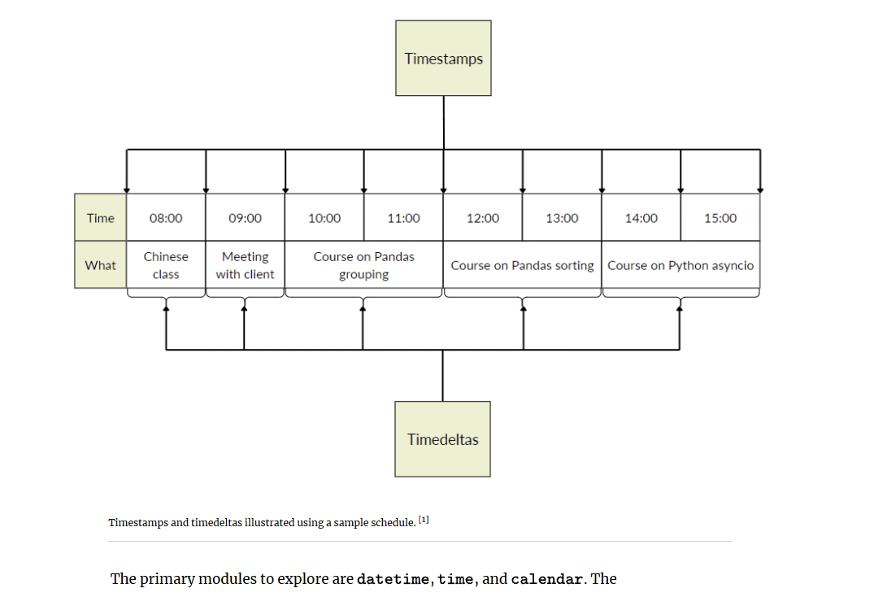

The primary modules to explore are datetime ,time , and calendar. The datetime.datetime type, often referred to simply as datetime, is widely used. For example, the following code snippet finds today's datetime date using which stores both the date and time down to the microsecond:
import datetime
now = datetime.datetime.now()
print(datetime.datetime(2022, 8, 12, 14, 9, 11, 337033))
print(now.year, now.month, now.day)
Temporal difference between two datetime objects can be computed using time delta, or simply timedelta . In general, we can say:

In other words, given two datetime objects, we can get an interval object representing the time between them. For example, given a birth date and a death date, we can calculate the length of someone’s life. And given a datetime and an interval, we can get the datetime on the other side of that interval. For example, given a meeting start time and its length, we can find out when it ends - or similarly, if given a meeting end time and its length, we can calculate when it started:
delta = datetime.datetime(2011, 1, 7) - datetime.datetime(2008, 6, 24, 8, 15)
The following:
from datetime import timedelta
delta = timedelta(
days=50,
seconds=27,
microseconds=10,
milliseconds=29000,
minutes=5,
hours=8,
weeks=2)
Results in the following three resulting normalized attributes:
datetime.timedelta(days=64, seconds=29156, microseconds=10)
You can format datetime objects and pandas Timestamps objects as strings using str or the strftime method, passing a format specification:
stamp = datetime(2011, 1, 3)
str(stamp)
stamp.strftime("%Y-%m-%d")
And finally, NaT (Not a Time) is pandas's null value for timestamp data.
You can parse a date with a known format using datetime.strptime) :
datetime.strptime(value, "%Y-%m-%d")
Pandas is generally oriented toward working with arrays of dates, whether used as an axis index or a column in a DataFrame. The pandas .to_datetimee method parses many different kinds of date representations. Standard date formats like ISO 8601 can be parsed quickly:
datestrs = ["2011-07-06 12:00:00", "2011-08-06 00:00:00"]
pd.to_datetime(datestrs)
DatetimeIndex(['2011-07-06 12:00:00', '2011-08-06 00:00:00'], dtype='datetime64[ns]', freq=None)
A time series object in pandas is a Series indexed by timestamps , which is often represented outside of pandas as Python strings or datetime objects:
dates = [datetime(2011, 1, 2), datetime(2011, 1, 5),
datetime(2011, 1, 7), datetime(2011, 1, 8),
datetime(2011, 1, 10), datetime(2011, 1, 12)]
ts = pd.Series(np.random.standard_normal(6), index=dates)
References
Reproduced from Lerner, R. (2024) Pandas workout: 200 exercises to make you a stronger data analyst. New York: Manning Publications Co. LLC.

Indexing Date and Time
Let's have a look at how time series behaves.
Time series behaves like any other Series when indexing and selecting data based on the label:
stamp = ts.index[2]
ts[stamp]
ts["2011-01-10"]
For longer time series, you can pass a year or a combination of year and month to easily select slices of data. The pandas.date_range function facilitates this process:
longer_ts = pd.Series(np.random.standard_normal(1000), index=pd.date_range("2000-01-01", periods=1000))
datetime can also be sliced and sliced with timestamps not contained in a time series to perform a range query. All of this and the above hold true for DataFrame as well, indexing on its rows:
dates = pd.date_range("2000-01-01", periods=100, freq="W-WED")
long_df = pd.DataFrame(np.random.standard_normal((100, 4)), index=dates, columns=["Colorado", "Texas", "New York", "Ohio"])
long_df.loc["2001-05"]

Frequencies
Frequencies in pandas consist of a base frequency and a multiplier.
Base frequencies are typically denoted by a string alias, such as M for monthly or H+ for hourly. Each base frequency corresponds to an object known as a date offset. For example, hourly frequency can be represented with the Hour class:
from pandas.tseries.offsets import Hour, Minute
hour = Hour()
You can define a multiple of an offset by passing an integer:
four_hours = Hour(4)
In most applications, you would use a string alias like “H” or “4H”. Putting an integer before the base frequency creates a multiple:
pd.date_range("2000-01-01", "2000-01-03 23:59", freq="4H")
Similarly, you can pass frequency strings, like “1H30min”, that will effectively be parsed to the same expression:
pd.date_range("2000-01-01", periods=10, freq="1h30min")
Finally, one useful frequency class is “week of month” starting with WOM. This enables you to get dates like the third Friday of each month:
monthly_dates = pd.date_range("2012-01-01", "2012-09-01", freq="WOM-3FRI")
list(monthly_dates)

Time Shifts and Resampling
Shifting refers to moving data backward and forward through time, resulting in missing data either at the start or the end of the time series.
Both Series and DataFrame have a shift method for performing naive shifts forward or backward, leaving the index unmodified:
ts = pd.Series(np.random.standard_normal(4), index=pd.date_range("2000-01-01", periods=4, freq="M"))
A common use of shift is computing consecutive percent changes in a time series or multiple time series as Dataframe columns. This is expressed as:
ts / ts.shift(1) - 1
Finally, resampling refers to the process of converting a time series from one frequency to another. Aggregating higher frequency data to lower frequency is called downsampling, while converting lower frequency to higher frequency is called upsampling. Not all resampling fits neatly into these categories; for example, converting from W-WED (weekly on Wednesday) to W-FRI is neither upsampling nor downsampling. Pandas objects are equipped with a resample method, which is the primary function for all frequency conversions. The resample method has a similar API to groupby; you call resample to group the data, then call an aggregation function:
dates = pd.date_range("2000-01-01", periods=100)
ts = pd.Series(np.random.standard_normal(len(dates)), index=dates)
ts.resample("M").mean()
ts.resample("M", kind="period").mean()

Conclusion
Time series data is vital across various fields and can be categorized as either fixed frequency, occurring at regular intervals, or irregular, without fixed time units. The method of marking and referring to time series data depends on the application and can include timestamps, fixed periods, intervals of time, or experiment/elapsed time. Understanding these distinctions is essential for accurately capturing and analyzing temporal data in diverse contexts.

- Having completed the exercise, take the opportunity to explore with your colleagues. Take a closer look at the plots after exploring them with multiple variables.
- What do you find interesting as you look at the data, that is, what do you notice from the scatter plots and density plots?
- Are there any correlations, and if so which ones? How strong are the correlations?

- Once you've submitted your response to the discussion forum, make sure to interact with at least two of your peers' contributions. Identify any similarities or disparities between your own response and theirs. What new perspectives or insights did you gain from their contributions?

Your Task
In Notebook 2.5, compare the sizes of the three niaaa-report files as well as the load time.
- What are your observations?
- Try much larger files. Are these observations still valid?
- Can you conclude when to use these format types?

Once you've submitted your response to the discussion forum, make sure to interact with at least two of your peers' contributions. Identify any similarities or disparities between your own response and theirs. What new perspectives or insights did you gain from their contributions?

